**doTable of Contents**

**Lab Setup Instructions** **2**

**Executing Commands in the Containers** **3**

**Change the container terminal name** **4**

**Important** **5**

**Finding the Network Interface of the Attacker Machine** **5**

# Once you have your SEED labs 20.04 VM setup, we will be performing all the experiments within this VM. There is no need to clone this VM as we will be creating docker containers within this VM to emulate this. This VM will henceforth be referred to as your host VM.

# Lab Setup Instructions

Along with each experiment there is a **Labsetup.zip** file, which contains the docker container configuration file required to set up the environment for each lab. Please use this link to download the zip file for sniffing and spoofing lab.

<https://seedsecuritylabs.org/Labs_20.04/Files/Sniffing_Spoofing/Labsetup.zip>

After downloading and extracting the lab setup file move into that directory and run the following command:

**# docker-compose build**

**#** **docker-compose up**

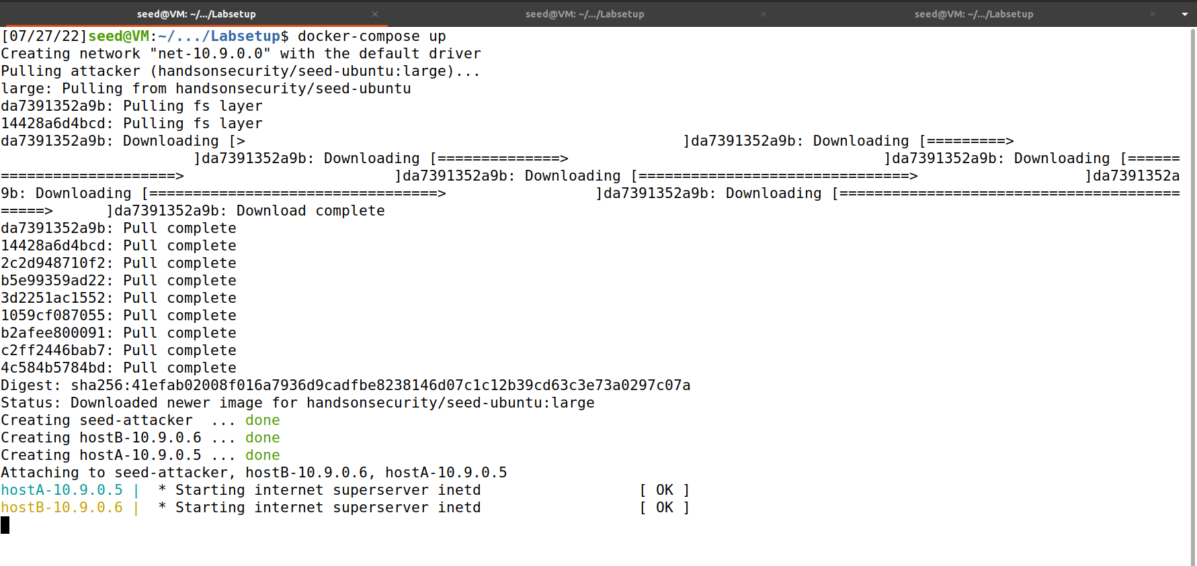

After running the commands open a new terminal window using the shortcut Ctrl + Shift + T or using the GUI.

In the newly opened terminal check if all the required containers have been deployed successfully using the following command :

**# docker ps**

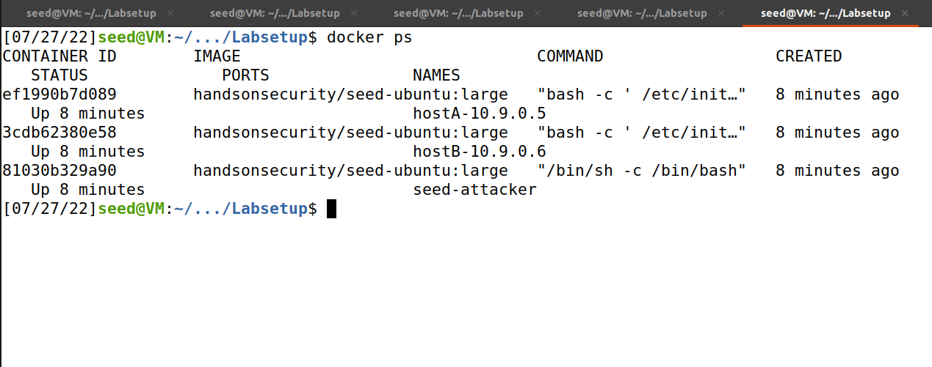

# Executing Commands in the Containers

All docker containers will run in the background. To access the various containers we just created and execute the attacks in, we must find the container's id. This is done using the previous “**docker ps”** command.

The first column shows the container IDs for each of the running containers and the names column gives you a description of that container.

To access and execute the commands inside the container we will use the docker exec command or the docksh command.

We will use the container ID of the docker container that we would like to login to in the command given below ie. replace **[ container ID ]** in the commands below with the required container ID.

**Commands** :

**# docker exec -it [ containerID ] /bin/bash**

**OR USE**

**# docksh [ container ID ]**

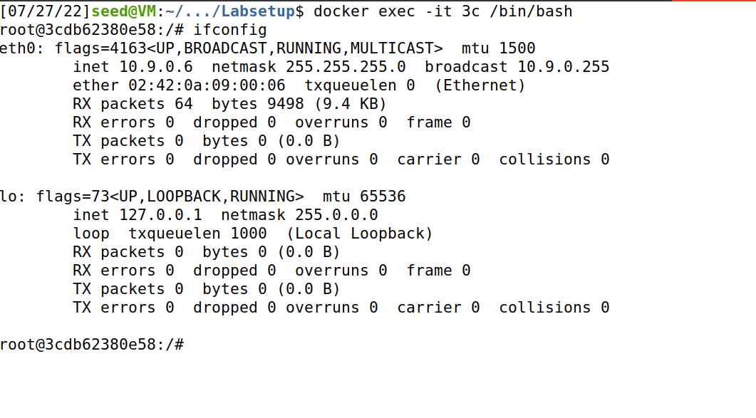

# Change the container terminal name

# 

**Change the terminal name in each container with the appropriate container name and SRN and name.**

If the terminal name is not changed, your lab will not be evaluated **AKA zero**.

**Run the command in the docker containers to change their names:**

**export PS1="seed-attacker:PES1UG20CSXXX:Name:\w\n\$>"**

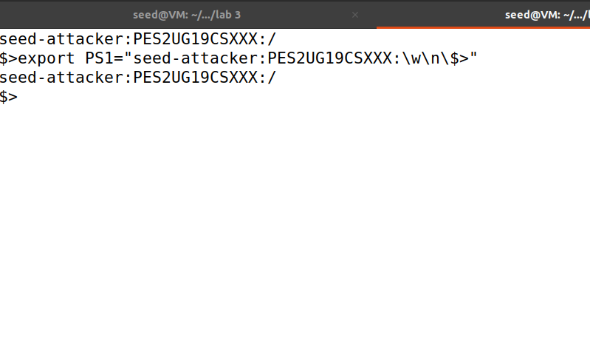

# Important

Within the container for the **attacker machine**, move to the **volumes** directory from the root directory before performing any of the experiments inside the containers. This stores the exploit files in the “**volumes**” folder inside the host VM. If not **all files that were created will be lost** when the containers are shut down.

**Command:**

**# cd volumes/**

# Finding the Network Interface of the Attacker Machine

The interface of the attacker machine's network adapter is required for most tasks in all labs and is the one displayed along with the attacker machine's IP address. In most cases the attacker machine's IP address is **10.9.0.1** and its interface is generated dynamically.

To get this we run the command :

**# ifconfig**

